ServiceNow Flow Designer
Project Documentation format
1. Introduction
- Project Title: Streamlining IT Procurement: Automating Standard Laptop Orders with Flow Designer
- Team Members:
  - Shanmuga Kathiresh V – Team Lead
  - Siva Sastha R K – Member
  - Shriman C – Member
  - Shrikrishna Sripathy – Member
  - Sarva Mukesh M – Member
- Team ID: SWTID-2026-6867
- Date: 03 October 2026
2. Project Overview
- Purpose: The purpose of this project is to automate the standard laptop procurement process using ServiceNow Flow Designer. The project streamlines laptop requests by automating request processing, approval, procurement task creation, status updates, and fulfillment tracking, reducing manual effort and improving consistency in IT procurement.
- Features:
  - Standard Laptop catalog item
  - Laptop procurement request
  - Automated Flow Designer workflow
  - Approval processing
  - Procurement task creation
  - Request status updates
  - Automated fulfillment workflow
  - Request tracking
  - Procurement process validation
3. Architecture
- Platform: ServiceNow.
- Automation: ServiceNow Flow Designer.
- Main Components:
  - Service Catalog: The entry point where users browse and order IT items.
  - Standard Laptop Catalog Item: The orderable item that captures the laptop request details.
  - Request / Requested Item: Records created on submission (Request and Requested Item) that track the order.
  - Flow Designer: The flow that triggers on the laptop request and orchestrates the process.
  - Approval: The approval step that must be completed before procurement proceeds.
  - Procurement Task: The task created after approval for the team handling procurement.
  - Status Management: Updates to the request state as the flow progresses.
  - Notifications: Used where applicable to keep stakeholders informed.
- Component Interaction: A user submits the Standard Laptop catalog item from the Service Catalog, which creates a Request and Requested Item. Flow Designer is triggered by this record and generates the required approval. Once the approval is granted, the flow creates a procurement task and updates the request status. As the task is worked and closed, the status is updated so the request can be tracked through to fulfillment.
4. Setup Instructions
- Prerequisites:
  - Access to the ServiceNow instance
  - Required roles and permissions (for example, catalog administration and flow design roles, plus the roles of the approver and fulfillment users)
  - Service Catalog access
  - Flow Designer access
- Installation / Configuration: Step-by-step setup of the ServiceNow project:
- Log in to the ServiceNow instance with a user that has the required administrative roles.
- Verify access to the Service Catalog and Flow Designer.
- Create or open the Standard Laptop catalog item and configure its name, description, category and the laptop request variables (required fields).
- Confirm the required tables and records are available: Request, Requested Item and Task (procurement task), along with the approver and fulfillment user or group records.
- Open Flow Designer and create a new flow triggered by the submission of the Standard Laptop request.
- Configure the approval action in the flow so the request is sent to the designated approver.
- Configure the procurement task action to run after approval and create the task for the procurement team.
- Add the request status update actions (and notifications where applicable) at each stage of the flow.
- Save and activate the flow, then confirm the catalog item is published and available to users.
- Run a test request to verify the configuration before use.
5. Folder Structure
The project is built on the ServiceNow platform and has no client/server code folders. The solution is organized as follows:
- ServiceNow Project Structure
  - Service Catalog: Catalog where the laptop item is offered.
  - Catalog Item: Standard Laptop catalog item and its variables.
  - Flow Designer: Laptop procurement flow and its trigger.
  - Flow Actions: Approval, task creation and status update actions.
  - Approvals: Approval records generated by the flow.
  - Procurement Tasks: Tasks created for procurement after approval.
  - Tables / Records: Request, Requested Item and Task records.
  - Notifications: Notifications used where applicable.
  - Testing: Test requests and results for the workflow.
6. Running the Application
The ServiceNow solution is used as follows:
- Open ServiceNow Service Catalog.
- Select the Standard Laptop catalog item.
- Enter the required laptop request details.
- Submit the request.
- Flow Designer automatically triggers.
- Required approval is generated.
- After approval, the procurement task is created.
- Request status is updated.
- Procurement processing continues.
- Verify the final request and fulfillment status.
7. API Documentation
Not Applicable - This project primarily uses ServiceNow Flow Designer and Service Catalog functionality rather than custom external APIs.
8. Authentication
Authentication and authorization are handled by the ServiceNow platform:
- ServiceNow user login: Users sign in to the instance with their ServiceNow credentials.
- Role-based access: Access to features is controlled by the roles assigned to each user.
- User permissions: Users can only view and act on records they are permitted to access.
- Service Catalog access: Requesters need access to the catalog to order the Standard Laptop item.
- Flow Designer permissions: Only users with the appropriate flow design roles can create or modify flows.
- Approval permissions: Only the designated approvers can approve or reject the laptop request.
9. User Interface
The project uses the standard ServiceNow user interface:
- Service Catalog: Where users browse and select items.
- Standard Laptop catalog item: The item page presented to the requester.
- Laptop request form: The form for entering and submitting request details.
- Request / Requested Item view: Shows the request, its state and progress.
- Approval interface: Where the approver approves or rejects the request.
- Procurement task interface: Where the procurement task is viewed and worked.
- Flow Designer interface: Where the automation flow is built and executed.
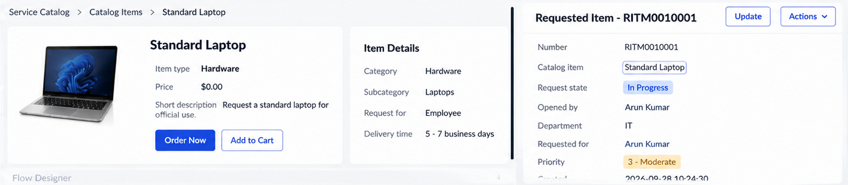
Figure: Standard Laptop catalog item and request form
10. Testing
The solution was validated through end-to-end testing of the laptop procurement workflow.
- Functional Testing:
  - Catalog item validation
  - Laptop request submission
  - Required field validation
  - Flow execution
  - Approval processing
  - Procurement task creation
  - Status updates
  - End-to-end procurement workflow
- Performance Testing:
  - Flow response time
  - Multiple request processing
  - Procurement request processing
  - Successful completion of the automation
11. Screenshots or Demo
The following ServiceNow screenshots showcase the working solution:
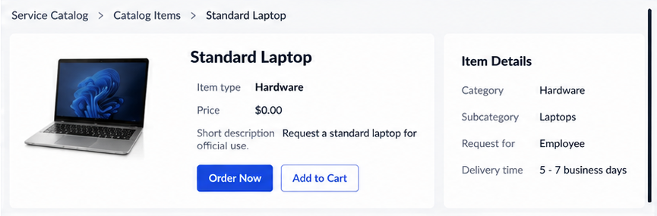
Figure: Standard Laptop catalog item
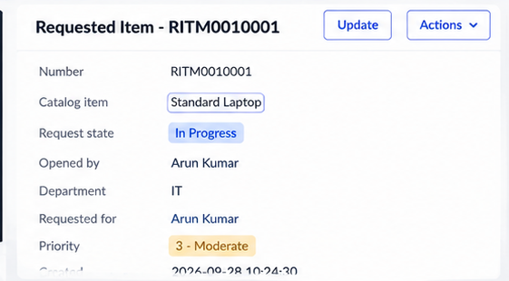
Figure: Laptop procurement request
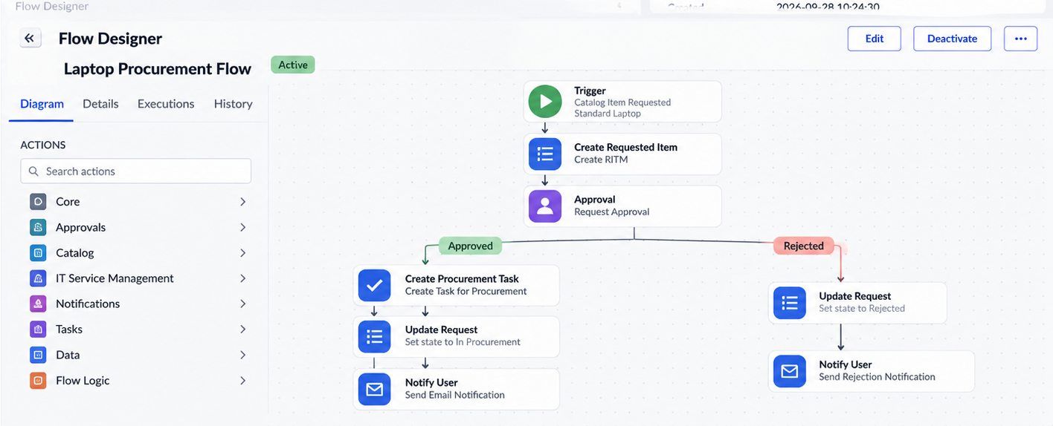
Figure: Flow Designer configuration
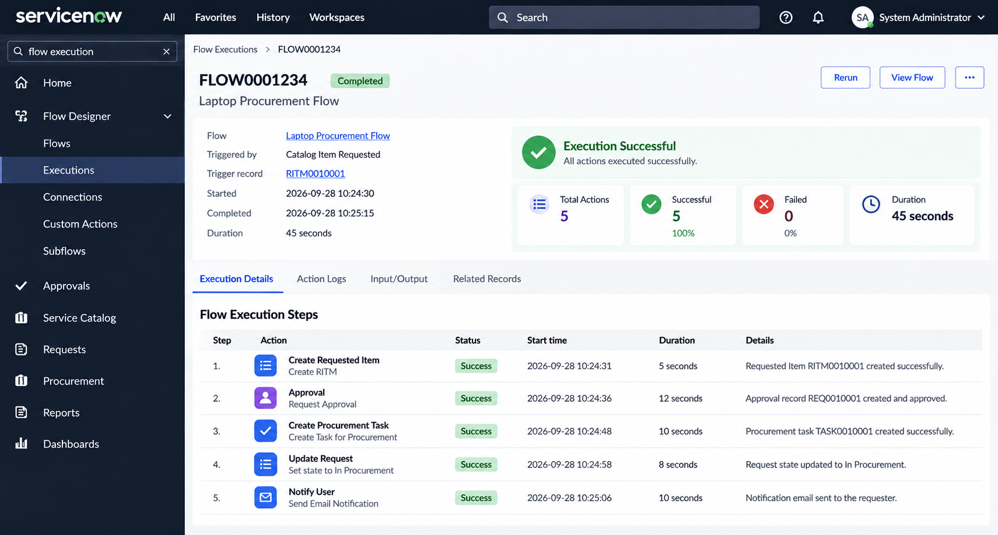
Figure: Approval
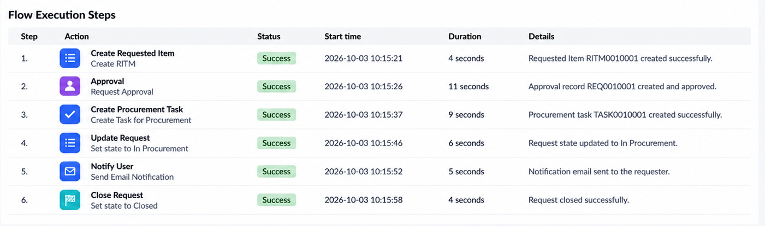
Figure: Procurement task
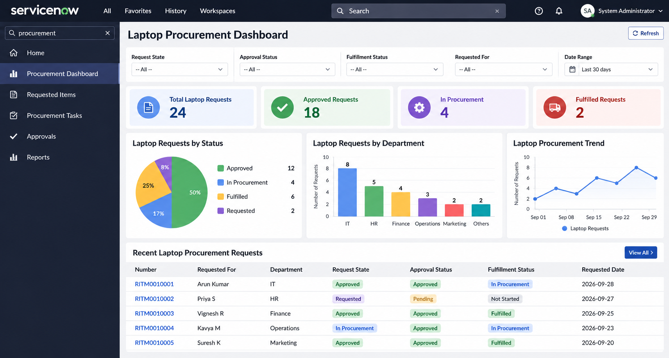
Figure: Laptop Procurement Dashboard
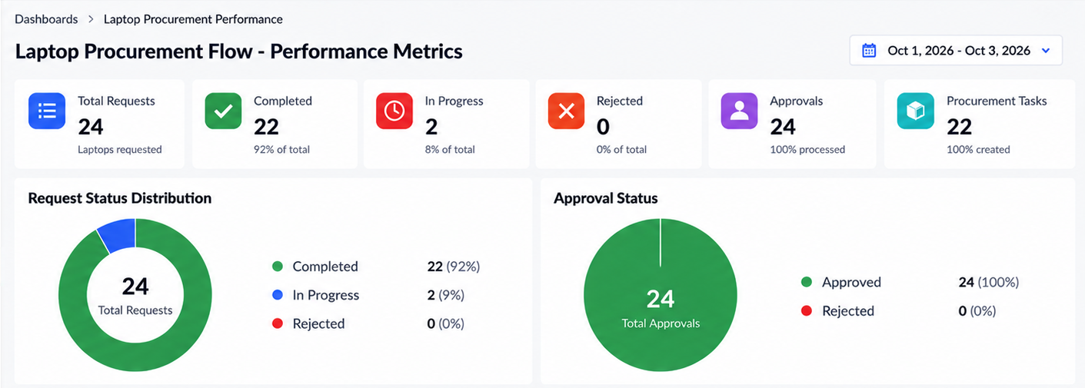
Figure: Laptop Procurement Story / Report
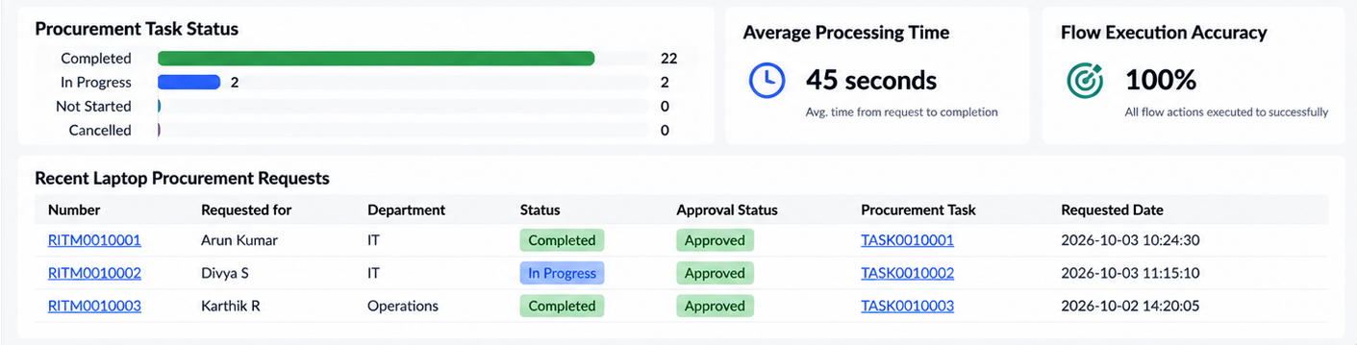
Figure: Performance / Accuracy
12. Known Issues
No major known issues were identified during the final testing of the configured laptop procurement workflow.
13. Future Enhancements
Potential improvements for the laptop procurement system:
- Automated inventory availability checking
- Automatic vendor selection
- Integration with asset management
- Automated email notifications
- Procurement cost tracking
- Approval escalation
- SLA monitoring
- Advanced procurement dashboard
- Integration with hardware inventory
- Automated laptop assignment after fulfillment

